APPLICATION FORM

PERSONAL INFORMATION

Surname: _________________________

First Name: _______________________

Date of Birth: _ _I_ _ I _ _ _ _

Gender: O female O male O diverse

Nationality: _______________________

Street, Nr. : ________________________

__________________________________

City, ZIP- Code: ___________________

Country: __________________________

Phone: ____________________________

Mobile: ___________________________

E-mail: ___________________________

Special Needs for mobility/nutrition:

__________________________________
__________________________________
Your motivation to apply for the COEUR Workshop: ___________________________________________________________________________
______________________________________________________________________________________________________________________________________________________

I herby confirm that the above information is complete and correct. I know that false information may lead to rejection of the application or exclusion from the participant panel without refund of payments made. I assure to pay the cost of the programme within 2 weeks after confirmation; otherwise the confirmation will expire automatically.
Place, Date Signature

General contact and requests: The COEUR Team, coeur@hs-mainz.de

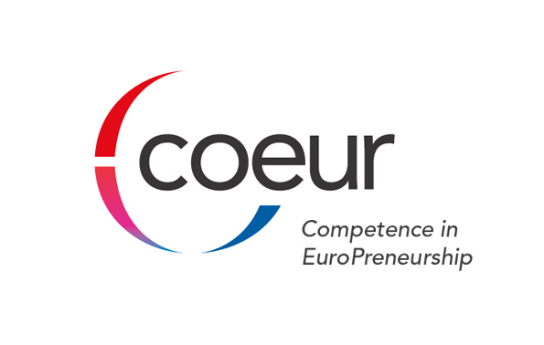

STUDY INFORMATION

COEUR Partner University:

__________________________________
Home University, if not identical with Partner University:

__________________________________

Faculty: ___________________________

Year of Study: _____________________

International semesters: ____________

Specialisation: ____________________

__________________________________

Academic degrees: _________________

Language Skills:

Language | Native | Fluent | Basic
English

__________________________________

